**Week 4_Spring REST_HandsOn**

**Hands on 1**

**Create a Spring Web Project using Maven**

**SpringLearnApplication.java**

package com.cognizant.springlearn;

import org.springframework.boot.SpringApplication;

import org.springframework.boot.autoconfigure.SpringBootApplication;

@SpringBootApplication

public class SpringLearnApplication {

public static void main(String[] args) {

System.out.println("SpringLearnApplication started...");

SpringApplication.run(SpringLearnApplication.class, args);

}

}

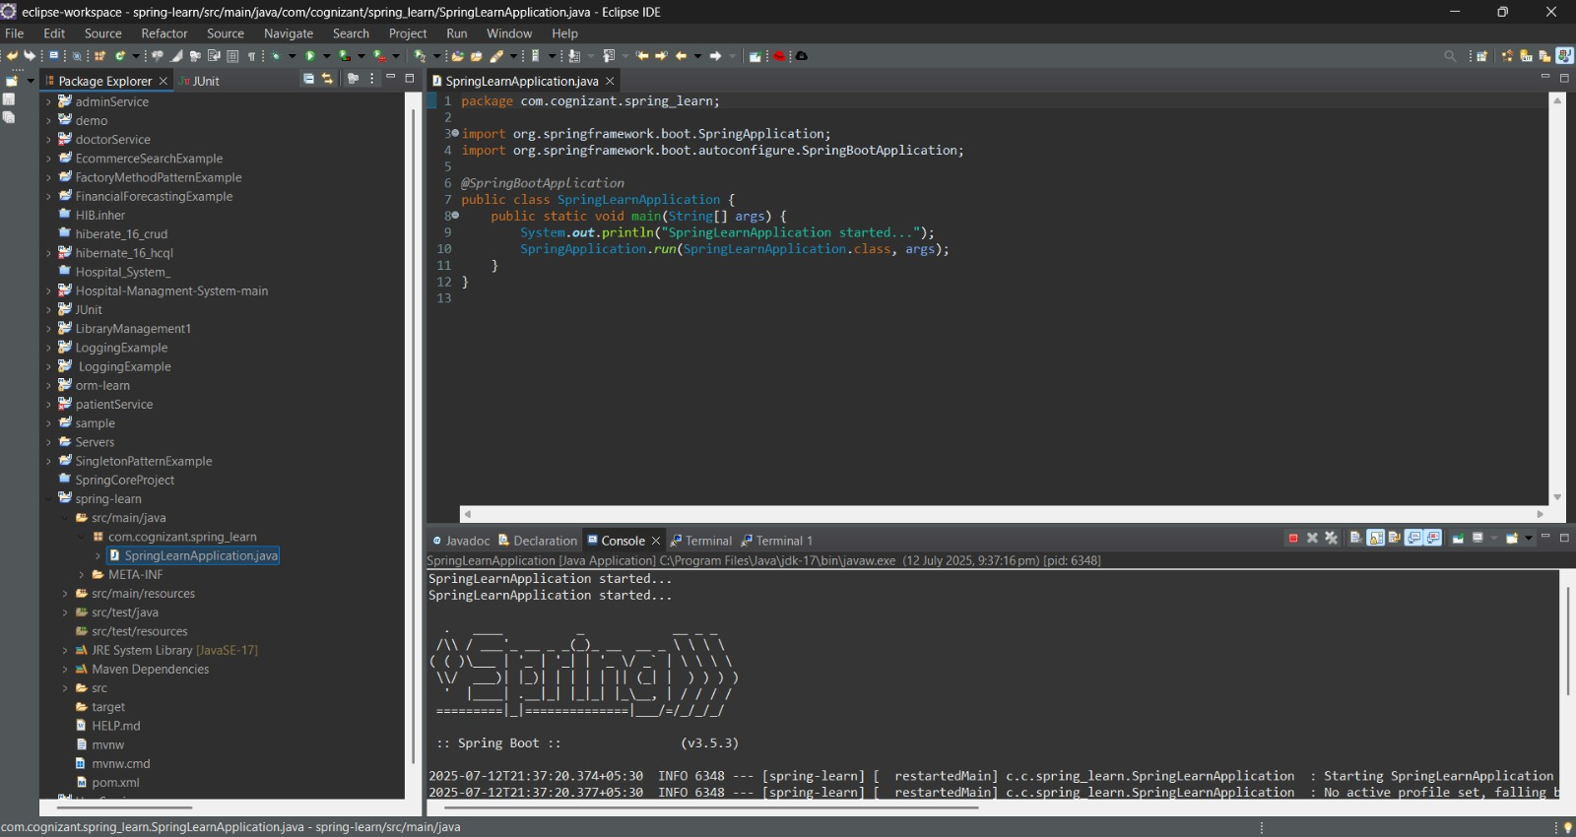

**Hands on 4**

**Spring Core – Load Country from Spring Configuration XML**

**Country.java**

package com.cognizant.springlearn;

import org.slf4j.Logger;

import org.slf4j.LoggerFactory;

public class Country {

private static final Logger LOGGER = LoggerFactory.getLogger(Country.class);

private String code;

private String name;

public Country() {

LOGGER.debug("Inside Country Constructor.");

}

public String getCode() {

LOGGER.debug("Inside getCode");

return code;

}

public void setCode(String code) {

LOGGER.debug("Inside setCode");

this.code = code;

}

public String getName() {

LOGGER.debug("Inside getName");

return name;

}

public void setName(String name) {

LOGGER.debug("Inside setName");

this.name = name;

}

@Override

public String toString() {

return "Country [code=" + getCode() + ", name=" + getName() + "]";

}

}

**SpringLearnApplication.java**

package com.cognizant.springlearn;

import org.slf4j.Logger;

import org.slf4j.LoggerFactory;

import org.springframework.context.ApplicationContext;

import org.springframework.context.support.ClassPathXmlApplicationContext;

@SpringBootApplication

public class SpringLearnApplication {

private static final Logger LOGGER = LoggerFactory.getLogger(SpringLearnApplication.class);

public static void main(String[] args) {

SpringApplication.run(SpringLearnApplication.class, args);

displayCountry();

}

public static void displayCountry() {

ApplicationContext context = new ClassPathXmlApplicationContext("country.xml");

Country country = context.getBean("country", Country.class);

LOGGER.debug("Country : {}", country.toString());

}

}

**country.xml**

<?xml version="1.0" encoding="UTF-8"?>

<beans xmlns="http://www.springframework.org/schema/beans"

xmlns:xsi="http://www.w3.org/2001/XMLSchema-instance"

xsi:schemaLocation="

http://www.springframework.org/schema/beans

http://www.springframework.org/schema/beans/spring-beans.xsd">

<bean id="country" class="com.cognizant.springlearn.Country">

<property name="code" value="IN" />

<property name="name" value="India" />

</bean>

</beans>

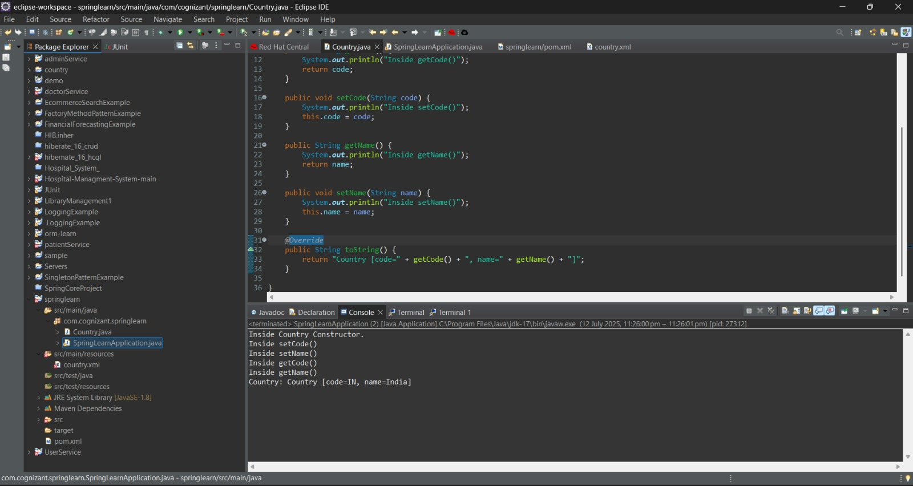

**Hello World RESTful Web Service - Hands On**

**HelloController.java**

package com.cognizant.springlearn.controller;

import org.slf4j.Logger;

import org.slf4j.LoggerFactory;

import org.springframework.web.bind.annotation.GetMapping;

import org.springframework.web.bind.annotation.RestController;

*@RestController*

public class HelloController {

private static final Logger *LOGGER* = LoggerFactory.*getLogger*(HelloController.class);

*@GetMapping*("/hello")

public String sayHello() {

*LOGGER*.info("START sayHello()");

String message = "Hello World!!";

*LOGGER*.info("END sayHello()");

return message;

}

}

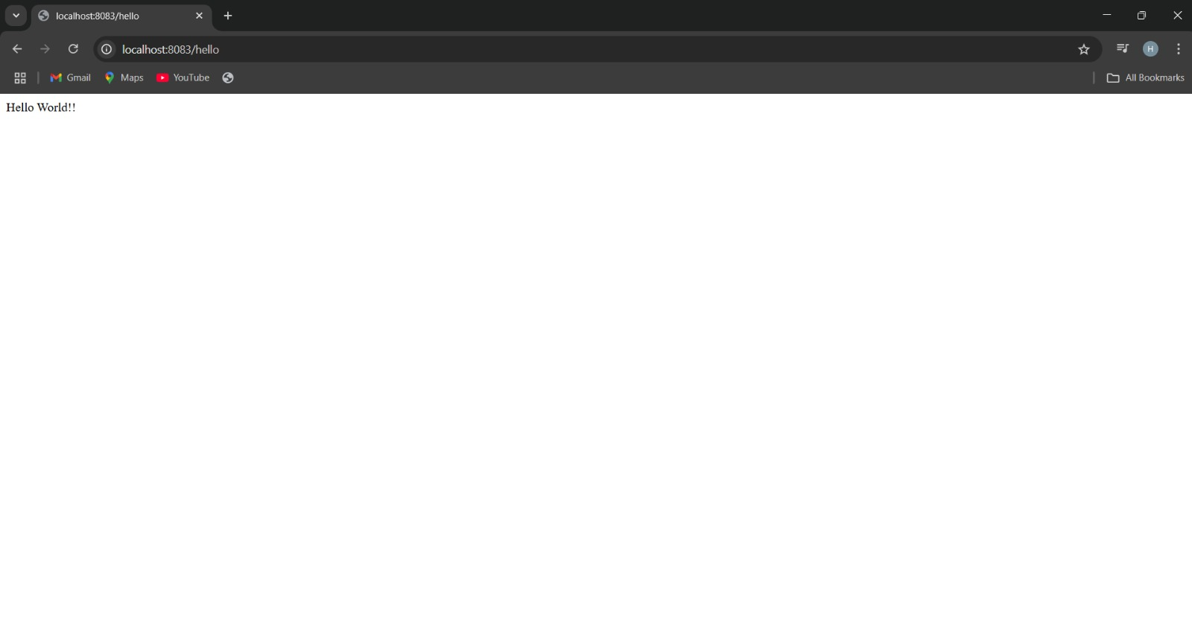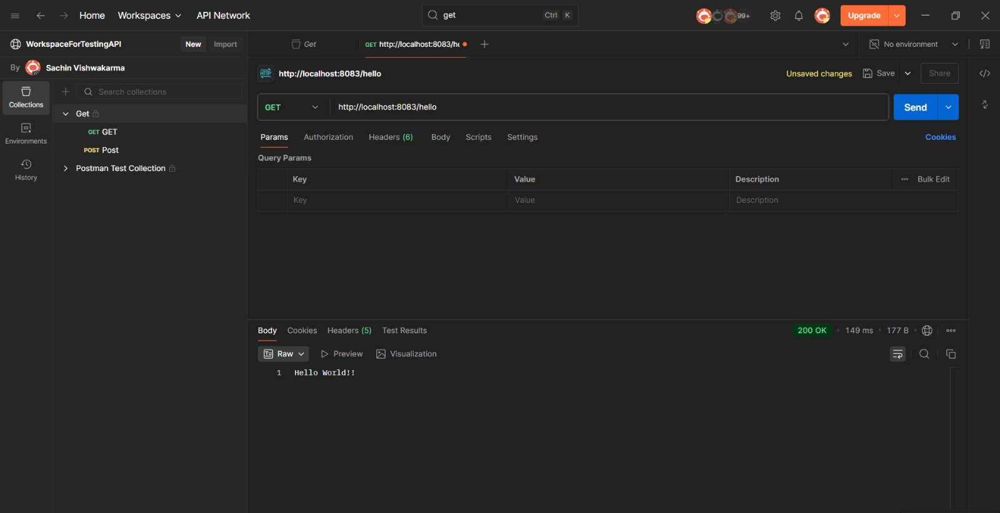

**REST - Country Web Service** - **Hands On**

**Country.java**

package com.cognizant.springlearn;

public class Country {

private String code;

private String name;

public String getCode() {

return code;

}

public void setCode(String code) {

this.code = code;

}

public String getName() {

return name;

}

public void setName(String name) {

this.name = name;

}

}

**CountryController.java**

package com.cognizant.springlearn.controller;

import com.cognizant.springlearn.Country;

import org.slf4j.Logger;

import org.slf4j.LoggerFactory;

import org.springframework.context.ApplicationContext;

import org.springframework.context.support.ClassPathXmlApplicationContext;

import org.springframework.web.bind.annotation.RequestMapping;

import org.springframework.web.bind.annotation.RestController;

@RestController

public class CountryController {

private static final Logger LOGGER = LoggerFactory.getLogger(CountryController.class);

@RequestMapping("/country")

public Country getCountryIndia() {

LOGGER.info("START getCountryIndia()");

ApplicationContext context = new ClassPathXmlApplicationContext("country.xml");

Country country = (Country) context.getBean("country");

LOGGER.info("END getCountryIndia()");

return country;

}

}

**country.xml**

<?xml version="1.0" encoding="UTF-8"?>

<beans xmlns="http://www.springframework.org/schema/beans"

xmlns:context="http://www.springframework.org/schema/context"

xmlns:xsi="http://www.w3.org/2001/XMLSchema-instance"

xsi:schemaLocation="http://www.springframework.org/schema/beans

https://www.springframework.org/schema/beans/spring-beans.xsd

http://www.springframework.org/schema/context

https://www.springframework.org/schema/context/spring-context.xsd">

<bean id="country" class="com.cognizant.springlearn.Country">

<property name="code" value="IN" />

<property name="name" value="India" />

</bean>

</beans>

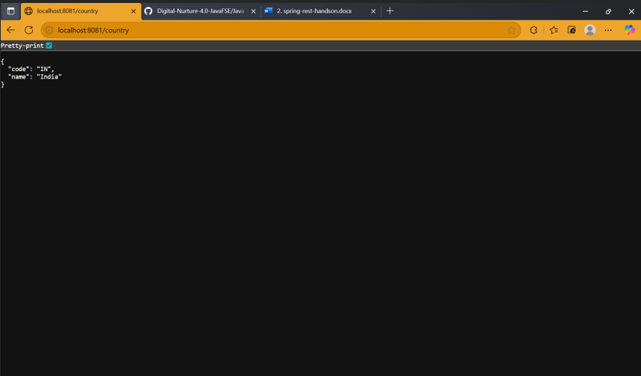

**REST - Get country based on country code – Hands On**

**CountryService.java**

package com.cognizant.springlearn.service;

import com.cognizant.springlearn.Country;

import org.springframework.context.ApplicationContext;

import org.springframework.context.support.ClassPathXmlApplicationContext;

import org.springframework.stereotype.Service;

import java.util.List;

@Service

public class CountryService {

public Country getCountry(String code) {

ApplicationContext context = new ClassPathXmlApplicationContext("country.xml");

List<Country> countryList = context.getBean("countryList", List.class);

return countryList.stream()

.filter(country -> country.getCode().equalsIgnoreCase(code))

.findFirst()

.orElse(null);

}

}

**CountryController.java**

package com.cognizant.springlearn.controller;

import com.cognizant.springlearn.Country;

import com.cognizant.springlearn.service.CountryService;

import org.slf4j.Logger;

import org.slf4j.LoggerFactory;

import org.springframework.beans.factory.annotation.Autowired;

import org.springframework.web.bind.annotation.*;

@RestController

public class CountryController {

private static final Logger LOGGER = LoggerFactory.getLogger(CountryController.class);

@Autowired

private CountryService countryService;

@GetMapping("/countries/{code}")

public Country getCountry(@PathVariable String code) {

LOGGER.info("START getCountry() with code: {}", code);

Country country = countryService.getCountry(code);

LOGGER.info("END getCountry()");

return country;

}

}

**Country.xml**

<?xml version="1.0" encoding="UTF-8"?>

<beans xmlns="http://www.springframework.org/schema/beans"

xmlns:xsi="http://www.w3.org/2001/XMLSchema-instance"

xsi:schemaLocation="http://www.springframework.org/schema/beans

https://www.springframework.org/schema/beans/spring-beans.xsd">

<bean id="countryList" class="java.util.ArrayList">

<constructor-arg>

<list>

<bean class="com.cognizant.springlearn.Country">

<property name="code" value="IN" />

<property name="name" value="India" />

</bean>

<bean class="com.cognizant.springlearn.Country">

<property name="code" value="US" />

<property name="name" value="United States" />

</bean>

<bean class="com.cognizant.springlearn.Country">

<property name="code" value="DE" />

<property name="name" value="Germany" />

</bean>

<bean class="com.cognizant.springlearn.Country">

<property name="code" value="JP" />

<property name="name" value="Japan" />

</bean>

</list>

</constructor-arg>

</bean>

</beans>

